IT7510 Capstone Semester 2 Year 2025
Learning Outcomes Tracking Application (LOTA)

Group Name: FAB
Group Members:
Frances Liu
Amarsh Tyagi
Bowang Ding


Client: Chalinor Baliuag
Organization: Whitireia and WelTec

Table of Contents
Project Objective 3
Client Background and Problem Overview 4
Deliverables 4
Scope of the Project 5
Project Requirements 6
Project Plan 6
Methodology 6
Technologies 8
Project budget 9
Project personnel 10
Client details 10
Group members 11
Project advisor 11
Communication plan 11
Conflict of Interest statement 12
RACI assessment matrix 12
Discussion of Appendix B: Capstone Project Client Contract 13
Discussion of Appendix C: NDA Requirement 13
Project timeline and milestones 14
Gantt Chart 15
Project Risk Analysis 15
References 21
Appendices 22
Appendix A: Gantt Chart 22
Appendix B: Capstone Project Client Contract 24
Appendix C: NDA Statement 29
Appendix D: Project Requirements 29
Must-have Functions 29
Nice-to-have functions 31

Project Objective
The Learning Outcomes Tracking Application (LOTA) is a technological solution to help the Information Technology School of Whitireia and WelTec to monitor and manage students Learning Outcomes (LOs) achievements in IT programs. The aim of developing this application is to enable stakeholders to track whether students pass or fail each individual LO evaluated in each assignment and exam across different selected courses. Stakeholders include students, tutors, and program managers. Program managers will behave as administrators. Initially, the project will be piloted with the Level 4 NZ Certificate in IT Essentials and Level 5 NZ Diploma in IT Technical Support. Then the application will include Level 6 and Level 7 IT programs. The application will be designed and developed with flexibility to accommodate future expansion to accommodate other IT programs.
To increase the design and functionality of our own project LOs Tracking Application, we examined the 4 different GitHub projects with similar goals. These examples will help us to build a better project by giving us ideas about UI and features.
- LOT_Final_Project (Wang, 2019) is a C# desktop application developed for the University of Utah’s CS4540 course. This application focuses on mapping assignments and exams to specific course outcomes. This project is important for linking assignments to learning goals and could help to inspire our own outcomes-assignments mapping module. While it is a desktop application, the backend logic and features are still applicable to our context.
- CS4540FinalProject (German, 2019) appears to be a web application, though documentation is limited. From what we can learn from this, it includes UI components for outcome tracking and goal metrics. Looking at this project will help us with designing UI components of web applications and use of APIs to communicate between backend and frontend.
- Desktop-OBE (Jan Ali, 2023) is centered around Outcomes-based Education (OBE) and will help to support managing curriculum-level outcomes. This likely includes tracking every student, reporting tools, and backend database. This structure is useful as they are models for reporting features, particularly if we aim to support more academic programs.
- University-CLO-s-Management (Shahid, 2024) is another C# project that helps to manage Course LOs and align them with teaching activities. This project will give us insight into support users like admin and instructor, and the database is nicely made. This will help us to structure our database and implement permission to access.
Overall, these projects give insight into different components which we can use to help build our own project LOTA. For example, from one of the projects, we will adopt a clear mapping of the assignments to course outcomes. Another project teaches us how to use role-based access and a well-organized backend. While these projects give us very useful insights into the project we will build, they lack a certain key aspect that is essential to our requirements, leaving a gap we will need to address.

Client Background and Problem Overview
The Information Technology School of Whitireia and WelTec aims to help and ensure that all students achieve all LOs in the programs. The New Zealand Qualifications Authority (NZQA) requires that all LOs in a course are successfully passed as a key overall requirement to pass a paper. For example, if an assignment assesses two LOs, a student may excel in the first LO while achieving a low score in the second one. Although the overall assignment may be passed, the student would still be considered as failing the second LO. In this case, the student should retake the specific failed LO to pass the assignment and the paper. Currently, tracking the achievements of these LOs is done manually by school staff. This way of working makes it difficult for program managers and tutors to manage and monitor the progress efficiently. Students also cannot have a clear understanding and view of which LOs they have passed or failed. The client, Chalinor Baliuag, the program manager of IT School of Whitireia and WelTec, seeks a functional, scalable, and convenient application to bridge this gap.

Deliverables
The LOTA project will provide a web-based platform for managing and monitoring student achievement of LOs in selected IT programs. The core deliverables for this project include:
- Project bid. It shows the team’s understanding of the project.
- Project proposal. This is a formal document that outlines and defines the detailed information of the project.
- A fully functional web-based application with IT programs from Level 4 to Level 7. This will allow all stakeholders to either just view or view, manage, and monitor the achievement of LOs. This can directly address the client’s requirement for managing the LOs efficiently and efficiently.
- Design document. This will include all design documents in all phases.
- System documentation. This will include technical documentation to support the application maintenance for the future.
- Testing documentation and reports. All the documents including testing plan, testing cases, and bug reports will be handed to the client.
- Client meeting agendas and minutes. All formal meetings with the client will be recorded. Information includes discussions, decisions, action items, and attendees. This will be helpful to ensure mutual accountability and understanding.
- Client conducting review video. The client can have a review of the final application to check whether the application meets the requirements.
- Client closeout report. This report is written to summarize the project outcomes and deliverables. This report is the closeout of the project.
Altogether, these deliverables will help the client to reduce the administration burden and enhance working efficiency.

Scope of the Project
The scope of this project includes the design and development of a web-based application to track the LOs of IT programs from Level 4 to Level 7. The pilot programs include the Level 4 NZ Certificate in IT Essentials and Level 5 NZ Diploma in IT Technical Support. Then it will expand to Level 6 and Level 7 IT programs. The application will ensure role-based access control, providing suitable permissions for all stakeholders. The students can view their achievement of each LO of the courses they selected. Tutors can create courses, import students to courses, and delete students. They can also view, add, update, and delete LOs and assessment weighting of their courses. Administrators have the same rights as tutors, and they also have the right to manage program level, instead of just managing a course level. The application will have an intuitive and user-friendly interface for all users.
Integration with Moodle and aPlus+ is out of scope of the project. The application will be web-based with full compatibility on both desktop and mobile browsers. Mobile versions and advanced analytical functions are excluded from the project. As per the client's requirement, the LOTA application will display only the status of each Learning Outcome (LO), including whether it has been passed or failed, along with the related assessments. The application will not provide recommendations on the number or type of retake tasks to assign for failed LOs, nor will it offer any guidance to tutors. For example, if a student fails the same LO across three assessments, the app will simply show that the LO was not achieved and list the related assignments. Decisions regarding retake tasks remain the responsibility of the tutors and are outside the scope of this project.

Project Requirements
The project requirements are divided into two categories. The must-have requirement’s part list essential functions for the LOTA. If there is still time left on the project timeframe, the team will proceed with the nice-to-have requirements, which are beneficial but not compulsory, please refer to Appendix D (see page 29).

Project Plan
This section explains the development plan of this project, including the methodology, technical solutions, and preliminary budget adopted. This project will combine the Scrum framework with the practice of extreme programming to promote the project in an agile development manner to ensure the continuous delivery of high-quality results in iterations.

Methodology
Scrum is a widely used framework in agile development that helps people, teams and organizations generate value through adaptive solutions for complex problems (Schwaber & Sutherland, 2020). It helps teams develop complex products in an iterative and incremental manner through structured processes. In Scrum, development work is divided into short cycles, called Sprints, and each Sprint usually lasts one to four weeks. Scrum emphasizes the self-organization ability of the team and encourages team members to share responsibilities. The entire process revolves around several core activities, including Sprint planning meetings, daily stand-up meetings, review meetings, and retrospective meetings. The core values of Scrum include transparency, inspection, and adaptation, which help teams continuously optimize workflows and respond to changes in a timely manner, thereby improving product quality and customer satisfaction.
Extreme Programming is an agile software development framework that aims to produce higher quality software and a higher quality of life for the development team (Agile Alliance, n.d.). It focuses on development efficiency and code quality, and advocates implementing excellent practices in programming in an extreme way, such as test-driven development, pair programming, continuous integration, frequent releases, and code refactoring. XP encourages development teams to maintain close communication with customers, respond quickly to changes in requirements, and ensure product stability and maintainability through technical means. The practice of XP has significant advantages in improving team collaboration efficiency, reducing software defects, and coping with rapid changes. It is especially suitable for environments with unstable project requirements or greater technical challenges.
Although there are many agile methodologies to choose from available ones, we deliberately made a decision not to choose Kanban for this project. Kanban is one of the methodologies that is widely recognized for its flexibility and its ability to help workflow using cards, boards, and work-in-progress limits. It excels in most environments like IT operations, customer service teams, or DevOps, where most of the tasks these teams perform are unpredictable and need to be handled continuously (Brigden, 2024). However, our project is different because it depends on more structure and predictability, especially regarding frequent planning, fixed delivery time, and defined development phases. Kanban operates more on a continuous flow basis without time-boxed iterations, which makes it harder to track progress in terms of milestones or deadlines (Wovchko, 2025).
Another key reason why we have not chosen Kanban is its lack of formal roles and ceremonies. Unlike Scrum, Kanban does not assign roles such as Product Owner or Scrum master, or Developer, nor does it include specific retrospective meetings, reviews, or planning. For a team like ours, focused on accountability, transparency, and route check-ins, those practices are very critical to the project as they help to ensure continuous improvement, and everyone is on the same page. Moreover, Kanban is a methodology as it does not dictate how the work should be done. It offers no help on how to practice code quality, integration, or testing, which is essential to our case. That is why we have also integrated Extreme Programming (XP), which is a methodology that brings together highly disciplined practices such as pair programming, test-driven development, and continuous integration.
Scrum and XP have different areas of expertise. Scrum provides a complete process framework for project management and team collaboration, such as Sprint, task decomposition, role division, and a periodic meeting mechanism, but it does not specify the technical methods for coding, testing, and deployment in detail. In contrast, Extreme Programming focuses on the technical practice of the software development process, emphasizing how to improve efficiency and quality at the coding level, but lacks a complete iterative project management framework.
Therefore, in an agile project that requires frequent delivery, rapid response to changes, and the desire to ensure code quality and team collaboration efficiency, it is a very natural and efficient approach to combine the management process of Scrum with the technical practice of XP. For example, after Sprint Planning determines the development tasks, the development team starts coding through test-driven development to reduce errors and uses continuous integration tools to ensure that the code is always deployable. Based on the project’s scope and workload, daily stand-up meetings will be adjusted to bi-weekly team meetings with additional ad hoc meetings as required. In the meetings, team members not only synchronize progress but also communicate technical difficulties and practical results. The review and retrospective phase at the end of the Sprint will also draw feedback from XP practices to continuously optimize the development process.
This integration will not only improve the controllability and transparency of the development process, but also significantly improve the technical quality of software delivery, forming an agile development system that has both organizational efficiency and technical support. Therefore, for LOTA project, the combination of Scrum and XP can allow the team to achieve high quality delivery, rapid response to needs.
Table 1 Comparison among different methodologies
Criteria | Scrum | Extreme Programming  (XP) | Kanban
Focus | Time-boxed iterations (Sprints), team collaboration, self-organization, and deliverables | Frequent releases and high customer involvement | Visual workflow management, continuous flow basis without time-boxed iterations
Workflow | Sprint cycles | Iterative cycles | use cards, boards, and work-in-progress limits
Adaptability | regular inspection and adaptation | respond quickly to requirement changes | minimal prescribed roles, less ceremonies, no specific retrospective meetings, reviews, or planning

Technologies
LOTA project will use a set of technologies and tools to support communication, project management, system design, development, and testing.
Communication Tools
For communication methods, emails will be used for formal communication and with the client. Both emails and WhatsApp will be used among team members to ensure timely and effective communication. The team will also use Zoom to have meetings. Zoom is a widely used conferencing platform, which will be the main method for weekly team meetings. For client and advisor meetings, the main method will be in-person meetings.
Management Tool
Atlassian (n.d.) describes Trello as a whiteboard-style management tool. It has lists of sticky notes, which are helpful and straightforward for the team to check the to-do list, status of tasks, and team member responsibilities (Atlassian, n.d.). Trello board can provide visual support for project management.
Design Tools
For system design tools, Draw.io and Visual Paradigm will be used. Draw.io is a diagramming tool which can be used to create various diagrams. Visual Paradigm is a professional tool to model different diagrams and models. It consists of a suite of tools that can be used for project development.
Development Tools
In development phase, Visual Studio 2022 will be used to code, debug, and compile the LOTA application. Visual Studio 2022 provides an integrated development environment (IDE) for the project. The team will adopt development languages like C#, SQL, JavaScript, and bootstrap.
Version Control Tool
GitHub, a cloud-based platform, will be used for version control by the team. Developers can use it to showcase, share, and manage the code, and track changes over time.
Testing Tools
For testing, xUnit will be used for unit testing. xUnit is a framework to facilitate testing individual units of code. It can ensure the reliability of codes. For integration testing, the team will use Excel spreadsheets to document and track test results manually. Excel is easy for recording and comparing the expected and actual test results. Selenium will be used in system testing. It is a widely used automation tool to test web applications. It can support various programming languages and can be run on different systems.

Project budget
There are no development costs for this project as it is built in-house using free and open-source tools, so the software license itself is also free of cost. However, later if the client decides the system should be deployed on a cloud platform like Microsoft Azure, operational costs may be involved. The research on Azure pricing calculator (https://azure.microsoft.com/en-us/pricing/calculator/) suggests that deployment would roughly cost around $60 - $100 per month depending on usage and confirmation.

Figure 1 Screenshot of Azure pricing calculator
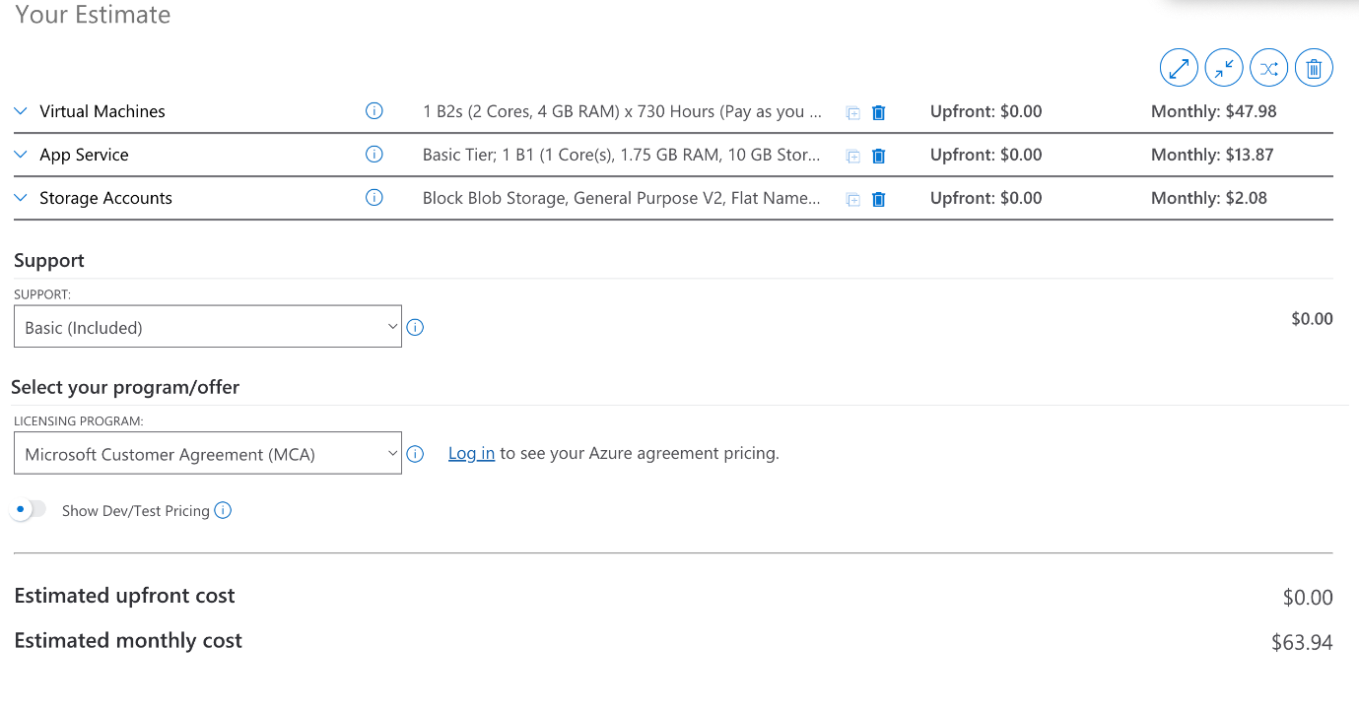

Project personnel
This section includes the important personnel involved in the LOTA project, including the client, group members, and the advisor. Each of them plays a significant role in the success of the project delivery.

Client details
Chalinor Baliuag is the Program Manager of the School of Information Technology at Whitireia and WelTec, which is a New Zealand’s Polytech institute of skills and technology. She has nearly twenty years of experience in tertiary education in both teaching and academic leadership. Chalinor has an in-depth knowledge and understanding of the delivery of curriculums and programs, and student performance evaluation metrics. She has taught a range of different software development courses. Her expertise in curriculum, teaching, and leadership is important to the LOTA program. Chalinor can bring valuable insights into the program. Her involvement will ensure that the LOTA application aligns well with expectations.

Group members
Frances Liu is the Project Manager and documenter of the project. She is responsible for the project coordination, project timeline management, team management, client communication, and advisor communication. She will also ensure that all documentation tasks, including reports, meeting agendas and minutes, and all deliverables, will be well documented and prepared and submitted in time. Frances will be responsible for part of the application design and testing tasks.
Amarsh Tyagi is the main tester and researcher. He will be responsible for overseeing the testing job to ensure that the application functions meet the requirements. He will contribute to the research activities, application design, and some of the development tasks when necessary.
Bowang Ding is the main developer and researcher. Bowang will lead the whole application development phase of the LOTA project. He will contribute to system design and coding. He will ensure that application development meets the requirements. He will also do research tasks, especially on methodologies, system design, and interface design. Bowang will assist with testing as needed.

Project advisor
Richa Panjabi is the advisor of the project. She has over ten years of experience in IT training. She provides the overall academic guidance to the team. Her experience and expertise in teaching and program mentoring will ensure that the project aligns with the course requirements throughout the whole project lifecycle.

Communication plan
Table 1 below outlines the methods of communicating with interested stakeholders. Communication with the client and the advisor is through emails. For the project group manager and members, they will also contact through WhatsApp, besides emails. Their WhatsApp accounts are also listed below.

Table 2 Communication plan table
Name | Email address
Client: Chalinor Baliuag | Chalinor.Baliuag@weltec.ac.nz  64 4 830 0713
Project Advisor: Richa Panjabi | richa.panjabi@weltec.ac.nz
Project manager: Frances Liu | chunguang.liu01@whitireianz.ac.nz liuchunguang321@163.com  WhatsApp: Frances Liu
Group member: Amarsh Tyagi | tyagiamarsh1@gmail.com  WhatsApp: ~ Amarsh Tyagi
Group member: Bowang Ding | bowang.ding01@whitireianz.ac.nz  WhatsApp: Bowang

Conflict of Interest statement
All group members have completed the Moodle choice about potentially relevant relationships with the client. Each of the group members confirmed that they do not have relationships with the client at Whitireia and WelTec.

RACI assessment matrix
RACI assessment matrix is a management tool to clarify the roles and responsibilities of tasks in the project (Matthews, 2024). The activities or deliverables should be listed; relevant roles should be assigned. Each role should be categorized as responsible, accountable, consulted, or informed. The role with responsibility performs tasks; the role with accountability ensures deadlines and completion; the role needs to be consulted provides valuable opinions and expertise; the role needs to be informed should be kept in the loop and updated (Matthews, 2024). Each activity should only have one accountable role. The RACI assessment matrix below (Table 2) shows the roles and responsibilities in LOTA project.

Table 3 RACI assessment matrix
Color Key:
Project deliverables
Academic deliverables

Project Activity/Deliverable | Project Manager (Frances Liu) | Developer  Researcher  (Bowang Ding) | Tester  Researcher  (Amarsh Tyagi) | Project Advisor (Richa Panjabi) | Client (Chalinor Baliuag)
Project bid | A, R | R | R | I | I
Team meetings | A, R | R | R | I
Advisor meetings | A, R | R | R | C
Client meetings | A, R | R | R | C, I | R
Weekly individual logbooks | A, R | R | R | I
Weekly group reports | A, R | R | R | C, I
Project proposal | A, R | R | R | C
Mid project progress presentation | A, R | R | R | C, I
Self-management review | A, R | R | R | C
Development (4 sprints) | A, R | R | R | C, | C
Client conducting review | A, R | R | R | C, I | C
Individual closeout report | A, R | R | R | C
Client closeout report | A, R | R | R | C, I | C
Academic closeout report | A, R | R | R | C
Academic style poster | A, R | R | R | C, I
One pager | A, R | R | R | C, I
Final panel presentation | A, R | R | R | C, I

Discussion of Appendix B: Capstone Project Client Contract
The signed Capstone Project Client Contract is included in Appendix B (see page 24).

Discussion of Appendix C: NDA Requirement
The client has confirmed via email selecting Option 1 Organisation Ownership in the Client Contract. Clear statement is included in Appendix C (see page 29).

Project timeline and milestones
This section outlines the key milestones and deliverables dates of the project (Table 3), including both the deliverables for the client and the academic requirements. Sprints 1 and 2 will last three weeks each, because these two sprints will focus on administrative functions which are the core and more complex functions of the application based on the client’s request. Sprints 3 and 4 will last two weeks each, which will cover tutor and student functions. Tutor functions are similar to administrative functions, and the student functions are limited to viewing information. These two sprints require less development effort compared to the first two sprints. A Gantt chart was created to assist visual presentation.

Table 4 Main milestones and deliverables dates
Color Key:
Project deliverables
Academic deliverables

Requirement | Academic week | Date | Due date
Project bid approved | Week 1 | 7th Jul - 13th Jul | 13th Jul
Project proposal | Week 2-4 | 14th Jul - 3rd Aug | 1st Aug
Sprint 1 | Week 4-6 | 28th Jul – 17th Aug | 17th Aug
Sprint 2 | Week 7-9 | 18th Aug – 7th Sep | 7th Sep
Mid-project progress presentation | Week 10 | 8th Sep – 10th Sep | 10th Sep
Sprint 3 | Week 10-11 | 8th Sep – 21st Sep | 21st Sep
Sprint 4 | Week 12-13 | 22nd Sep – 5th Oct | 5th Oct
Self-management review | Week 13 | 29th Sep – 5th Oct | 1st Oct
Client conducting review | Week 14 | 6th Oct – 12th Oct | 17th Oct
Individual closeout report | Week 15 | 13th Oct – 19th Oct | 17th Oct
Client closeout report | Week 15 | 13th Oct – 19th Oct | 17th Oct
Academic closeout report | Week 15 | 13th Oct – 19th Oct | 17th Oct
Academic style poster | Week 15 | 13th Oct – 19th Oct | 17th Oct
One Pager | Week 15 | 13th Oct – 19th Oct | 17th Oct

Gantt Chart
For the project timeline Gantt Chart, please refer to Appendix A (see page 22).

Project Risk Analysis
The risk assessment matrix is a very important table used to identify, evaluate, and prioritize potential risks within our project. This helps to visualize the likelihood of the different risks occurring against the severity of their impact. This will help our team to decide which risks require immediate action. The matrix below is categorized as negligible, minor, moderate, major, and catastrophic. This is to help team members make informed decisions. This following table will help to provide a more detailed analysis of risk in the LOTA project.

Table 5 Risk Assessment Matrix
Color Key:
Low
Medium
High

 | Severity
Likelihood | 1  Negligible | 2  Minor | 3  Moderate | 4  Major | 5  Catastrophic
5  very Likely | 5 | 10 | 15 | 20 | 25
4  Probable | 4 | 8 | 12 | 16  RISK-019 | 20
3  Possible | 3 | 3  RISK-002  RISK-003 | 9  RISK-013 | 12  RISK-008  RISK-009  RISK-012 | 15
2  Not Likely | 2 | 4 | 3  RISK-001  RISK-004  RISK-007 | 8  RISK-005  RISK-011  RISK-015 | 10
1  Very Unlikely | 1 | 2 | 3  RISK-006 | 4  RISK-010  RISK-014 | 5  RISK-016  RISK-017  RISK-018

A risk mitigation plan outlines strategies to reduce the likelihood or occurrence of identified risks. This would include preventive actions, resource planning, and timeline to manage potential issues more on hand. Table 5 below will help to ensure continuity, minimize disruption, and make informed decisions if the project encounters a risk.

Table 6 Risk Mitigation Plan
Risk Code | Risk | Mitigation
RISK-001 | Internet Downtime | Use mobile hotspot, if possible, record meetings so can be watched later.
RISK-002 | Minor Technical Bugs | Make sure to do continuous testing during development, log the one you fixed.
RISK-003 | Brief task delay caused of a minor illness | Share your projects with your teammates regularly, allowing them to get well soon.
RISK-004 | Feedback not accepted | Conduct more meetings with clients and require validation.
RISK-005 | Late Feature Delivery | Prioritize important features  So, they get finished first and implement sprints.
RISK-006 | Missed reviews | Set automatic reviews after every sprint, assign a review lead for each sprint.
RISK-007 | Git version control mismanagement | Make sure all team members know how to use Git properly. Assign a designated person to oversee. Keep backing up branch.
RISK-008 | Tool crash during test | Use stable software versions rather than beta versions and keep backups.
RISK-009 | Uncontrolled scope creep | Stop scope after initial planning, implement strict control process.
RISK-010 | UI bug on demo day | Perform pre-demo check on the web application.
RISK-011 | Development tool failure | Regularly back up your work and have an alternative tool ready in case.
RISK-012 | Vague requirements | Make sure to clarify requirements from the client via multiple meetings, create a requirement document.
RISK-013 | Negative user feedback | Conduct early testing to make sure the web application is user friendly.
RISK-014 | Member drops out | Make sure to keep up to date with all the other members' activities via their work and documents.
RISK-015 | Illness during the last sprint | Maintain flexible task assignments.
RISK-016 | Entire Requirement missed | Use a traceability matrix, which would help to double check with the client. Also seek advice from the client and advisor.
RISK-017 | Data breach | Put strong access control, encrypt data, and perform regular security tests.
RISK-018 | Personal information leaked | Use anonymized data and implement admin restrictions.
RISK-019 | Scope changes post-plan | Lock scope with stakeholder approval.

A risk contingency plan outlines the backup action in case a risk occurs despite the mitigation efforts. This would help to ensure that the project can respond quickly and effectively to unexpected events and minimize the impact. This table 6 helps to provide alternative solutions, resource allocation, and guidance to make decisions to make sure the project does not get off track.

Table 7 Risk Contingency Plan
Risk Code | Risk | Contingency
RISK-001 | Internet Downtime | Use mobile hotspot or sync offline work later
RISK-002 | Minor Technical Bugs | Log bugs and fix them during different sprints
RISK-003 | Brief task delay caused of a minor illness | Shift tasks to a different team member and adjust the timeline.
RISK-004 | Feedback not accepted | Have an instant meeting to realign goals.
RISK-005 | Late Feature Delivery | Work on important features that are viable for the web application.
RISK-006 | Missed reviews | Hold a review meeting to help solve the backlog of missed reviews.
RISK-007 | Git version control mismanagement | Assign a designated person to resolve conflicts immediately. Use a backup from last version.
RISK-008 | Tool crash during test | Use a different backup tool or notify the delay to the client.
RISK-009 | Uncontrolled scope creep | Have a meeting with the client to lock down the scope.
RISK-010 | UI bug on demo day | Use a demo video or ask the panel to have the demo on another day.
RISK-011 | Development tool failure | Have a backup development tool and delay the non-critical features.
RISK-012 | Vague requirements | Contact the client for an emergency meeting.
RISK-013 | Negative user feedback | Take into consideration the suggested changes and fix them before the next sprint.
RISK-014 | Member drops out | Reassign work or ask for an extended deadline.
RISK-015 | Illness during the last sprint | Temporarily reassign tasks while keeping the sick members up to date.
RISK-016 | Entire Requirement is missed | Add to the next release of the web application.
RISK-017 | Full data breach | Inform your team members and trigger breach protocols.
RISK-018 | Personal information leaked | Stop distributing the affected build which leaks personal information and patch it with security measures.
RISK-019 | Scope changes post-plan | Change the plan for the next sprint so that it includes the scope of changes.

References
Agile Alliance. (n.d.). Extreme Programming (XP). https://agilealliance.org/glossary/xp/
Asana, T. (2025, February 25). Risk Matrix Template: Assess Risk for Project Success [2025] • Asana. Asana. https://asana.com/resources/risk-matrix-template
Atlassian. (n.d.). What is Trello? Trello Help. https://support.atlassian.com/trello/docs/what-is-trello/
Brigden, B. (2024, April 22). Kanban vs. Scrum: A simple breakdown of each complex
methodology. Teamwork.com. https://www.teamwork.com/blog/kanban-vs-scrum/‌
German, V. (2019). CS4540FinalProject [Computer software]. GitHub. https://github.com/ValerieGerman7/CS4540FinalProject
Jan Ali, S. (2023). Desktop-OBE [Computer software]. GitHub. https://github.com/SaqlainJanAli/Desktop-OBE
Matthews, B. (2024, December 9). What is a RACI matrix? Definition, examples, uses. Project-Management.com. https://project-management.com/understanding-responsibility-assignment-matrix-raci-matrix/
Schwaber, K., & Sutherland, J. (2020). The Scrum Guide: The definitive guide to Scrum: The rules of the game. Scrum.org. https://scrumguides.org/scrum-guide.html
Shahid, A. (2024). University-CLO-s-Management [Computer software]. GitHub. https://github.com/ahmarshahid/University-CLO-s-Management
Wang, K. (2019). CS4540_Final_Project_LOT [Computer software]. GitHub. https://github.com/kenmingwang/CS4540_Final_Project_LOT
Wovchko, B. (2025, June 10). When Kanban is the Better Choice. Mountain Goat Software.
https://www.mountaingoatsoftware.com/blog/when-kanban-is-the-better-choice

Appendices

Appendix A: Gantt Chart
Figure 2 Overview screenshot of the Gantt Chart
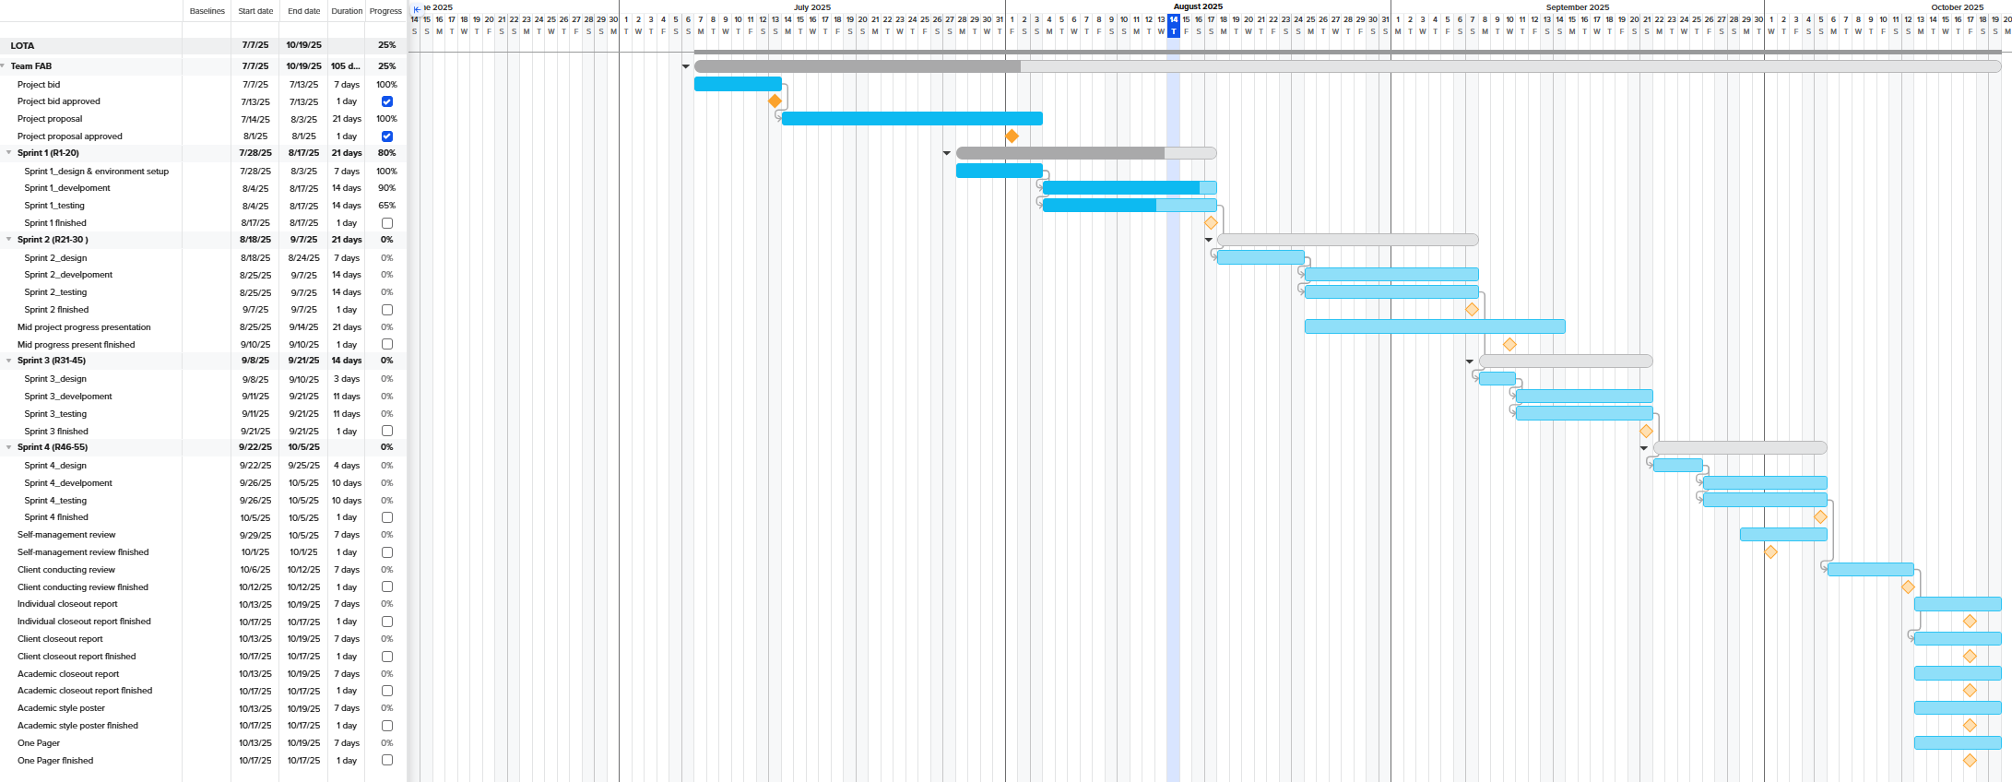

Figure 3 Screenshot of the Gantt Chart timeline
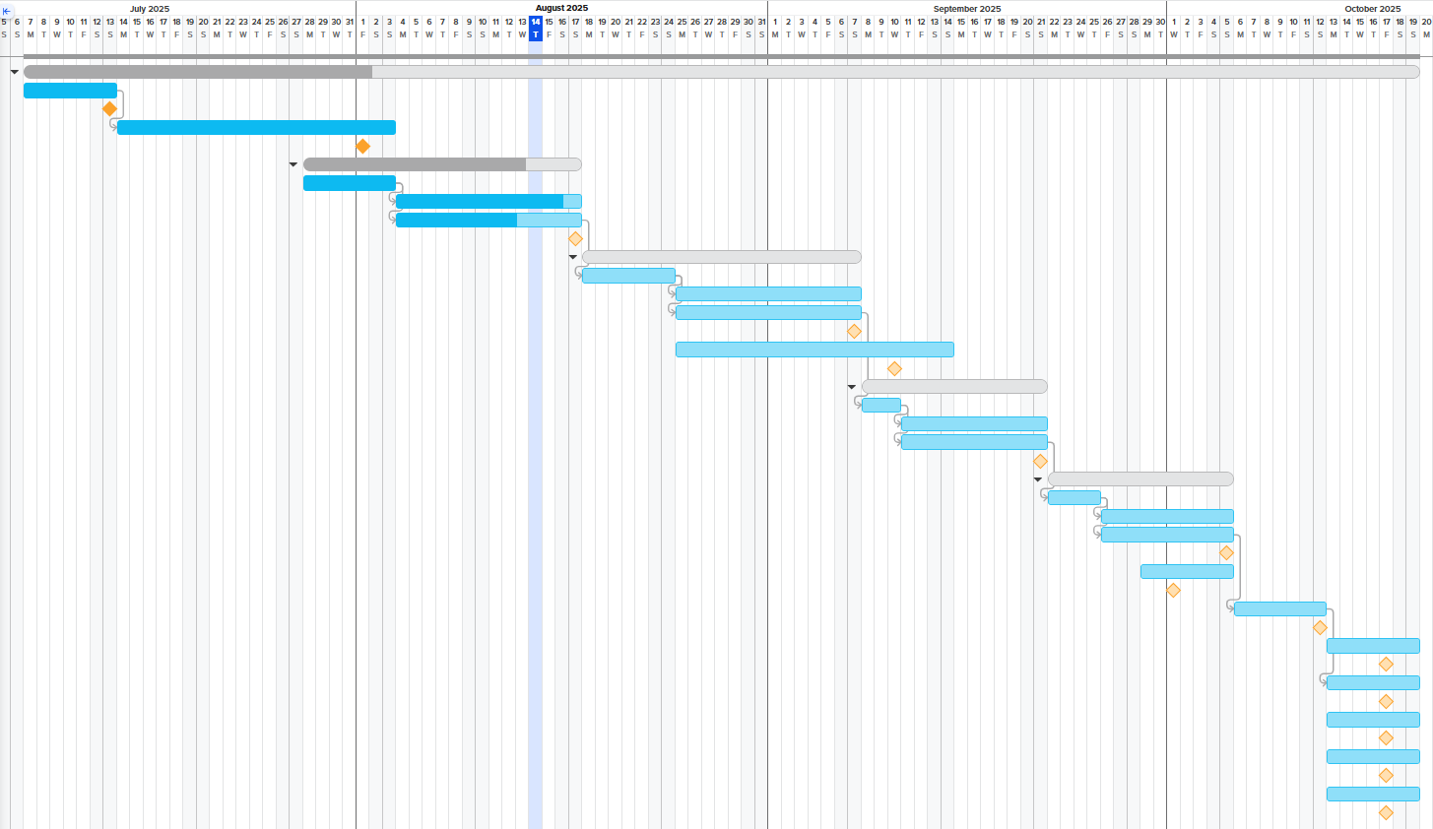

Figure 4 Screenshot of the Gantt Chart task list
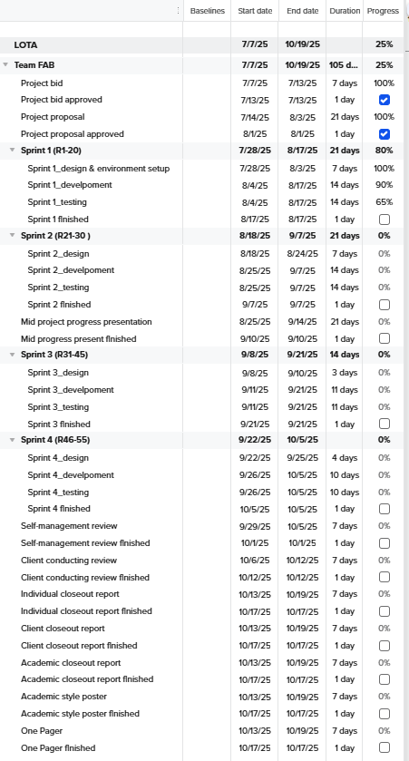

Appendix B: Capstone Project Client Contract

IT7510 Project Client Contract
WHITIREIA and WELTEC NEW ZEALAND
SCHOOL OF INNOVATION, DESIGN and
TECHNOLOGY PROJECT AGREEMENT

The Parties

This Student(s) Project Agreement (the “Agreement”) is made between:
- Whitireia and Weltec New Zealand School of Innovation, Design and Technology (the “Faculty”);
- the nominated computing student(s) (the “Student(s)”) (as listed under section 6); and Whitireia and Weltec New Zealand School of Innovation, Design and Technology the proposed Industry Organisation (the “Organisation”).

BACKGROUND

- As part of an established course of study at the Faculty, Bachelor of Information Technology students take a course module IT7x01, in which the Student(s) completes a project (“the Project”) with the Organisation on the basis set out in this Agreement.
- The Organisation agrees to allow the Student(s) access to its premises if needed to undertake that Project on the basis set out in this Agreement.
- The Faculty is satisfied that the Organisation is suitable for the Student(s) Project.

TERMS

      - Effective Date

This Agreement shall be effective as of 7th July 202 until 31st October 2025 .

      - Undertakings

  - The Organisation has accepted the Student(s) and agrees to allow that Student(s) access to its premises as needed.
  - The Organisation agrees to be responsible for meeting the requirements of its statutory obligations, e.g. Health and Safety in Employment Act, Human Rights Act, etc., for the Student(s).
  - The Student(s) will use their best efforts in undertaking the Project for the Organisation, as mutually agreed by the parties and set out in a separate written proposal which will form part of this Agreement.
  - The Organisation understands that the primary reason for the Project is education and advancement of knowledge, and, consequently, the Project must further that purpose.
  - Neither the Faculty nor the Student(s) guarantee specific results and the Project will be undertaken only on a best efforts basis.
  - The Student(s) agrees to submit their IT7510 report to their nominated supervisor at the Organisation.

      - Copyright, Patents, Trade Marks and other Intellectual Property Rights

The Faculty and Student(s) each acknowledge that all copyright, trademarks, trade names, patents and other intellectual property rights belonging to the Organization that the Faculty and Student(s) come into contact with are and shall remain the sole property of the Organization, and no claim or right to them is to be made by or created in the Faculty or Student(s).

      - Confidential Information

4.1 The parties may wish, from time to time, in connection with the Project undertaken under this Agreement, to disclose certain information of a confidential nature (“Confidential Information”) to each other. Each party will use reasonable efforts to prevent the disclosure of any of the other parties Confidential Information to third parties for a period of three (3) years from receipt of that information, provided that the recipient party’s obligation shall not apply to information that:
- is not disclosed in writing or reduced to writing and marked with an appropriate confidentiality legend or designated in writing as Confidential Information within thirty (30) days of disclosure;
- is already in the recipient party’s possession at the time of disclosure;
- is or later becomes part of the public domain through no fault of the recipient party;
- is received from a third party having no obligations of confidentiality to the disclosing party;
- is independently developed by the recipient party; or
- is required by law or regulation to be disclosed.

  - Application may be made to any party for written permission to use Confidential Information. No party shall unreasonably withhold such permission.
  - If permission to use Confidential Information is withheld by a party, then that party will state the reason or basis for refusal of permission.

      - Intellectual Property Rights
  - The parties agree that both the Faculty and the Student(s) may use the intellectual property rights that are created as a result of the Project work undertaken by each Student for the Organization for portfolio purposes to promote the Faculty and/or the Student(s).
  - The following intellectual property rights are agreed between the parties:

(Please indicate which option is agreed upon by placing a tick in the appropriate box and deleting the options that do not apply.)

Option 1 – Organization Ownership:
√
All intellectual property rights that are created as a result of the Project work undertaken by the Student(s) for the Organization shall vest absolutely in the Organization.

Option 2 – Student(s) Ownership:
All intellectual property rights that are created as a result of the Project work undertaken by each Student for the Organization shall vest absolutely in each respective Student. Each Student hereby grants the Organization, and where more than one Student has been involved in the Project, the other Student(s) are granted, a perpetual non-exclusive license for that intellectual property.

Option 3 – Split Ownership
There shall be two types of intellectual property:
- Custom property (being intellectual property specifically developed by the Student(s) for the Organisation)
- Generic property (being any intellectual property not specifically developed by the Student(s) for the Organisation)
The Custom property will be vested solely in the Organization whereas Generic property will vest solely in each respective Student. Each Student hereby grants the Organization and where more than one Student has been involved in the Project, the other Student(s), a perpetual non-exclusive license for that Generic property.

Option 4 – Client NDA and any other intellectual property rights
(Please attach here any other intellectual property rights agreed between the parties)

      - Signatures

Project Name Learning Outcomes Tracking Application (LOTA)

Role | Name | Signature | Date
Project Client/ Organization Representative
Representative of Whitireia New Zealand/ Faculty Representative
Student | Frances Liu | Frances Liu | 11th August 2025
Student | Bowang Ding | Bowang Ding | 11th August 2025
Student | Amarsh Tyagi | Amarsh Tyagi | 11th August 2025

Appendix C: NDA Statement
No additional Non-Disclosure Agreement is required beyond the terms in Option 1 by the client.

Figure 5 Screenshot of the client option about Intellectual Property Rights
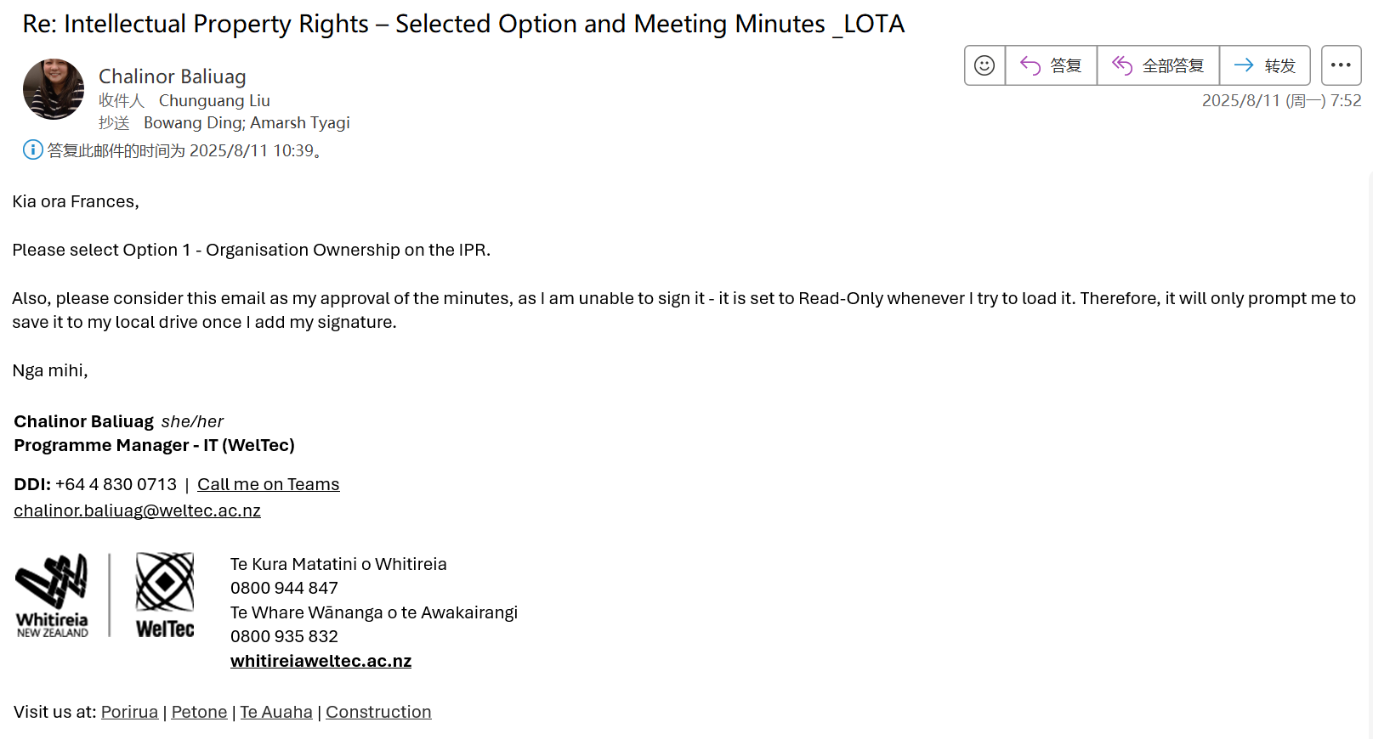

Appendix D: Project Requirements

Must-have Functions
- Admin should be able to add new course information.
- Admin should be able to update course information.
- Admin should be able to delete course information.
- Admin should be able to add new tutor information.
- Admin should be able to update tutor information.
- Admin should be able to delete tutor information.
- Admin should be able to add new student information.
- Admin should be able to update student information.
- Admin should be able to delete student information.
- Amin should be able to view tutor information.
- Amin should be able to view course information.
- Amin should be able to view student information.
- Admin should be able to view qualification information.
- Admin should be able to add qualification information.
- Admin should be able to edit qualification information.
- Admin should be able to delete qualification information.
- Admin should be able to view Trimester information.
- Admin should be able to add Trimester information.
- Admin should be able to edit Trimester information.
- Admin should be able to delete Trimester information.
- Admin should be able to view all assignments/exam's LOs.
- Admin should be able to view all assignments/exam's LOs by filtering course’s name.
- Admin should be able to add new assignments/exam's LOs for tutor.
- Admin should be able to update new assignments/exam's LOs for tutor.
- Admin should be able to delete new assignments/exam's LOs for tutor.
- Admin should be able to release results of assignments/exam's LOs to students
- Admin should be able to update results of assignments/exam's LOs that were released
to students.
- Admin should be able to delete results of assignments/exam's LOs that were released
to students.
- Admin should be able to set the retake of the failed assignments/exam's LOs to
students.
- Admin should be able to update results of assignments/exam's LOs to students who
attended retake.
- Tutor should be able to add new student information.
- Tutor should be able to update student information.
- Tutor should be able to delete student information.
- Tutor should be able to view course information.
- Tutor should be able to view student information.
- Tutor should be able to view all their assignments/exam's LOs.
- Tutor should be able to view all their assignments/exam's LOs by filtering their
course’s name.
- Tutor should be able to add new assignments/exam's LOs for tutor.
- Tutor should be able to update new assignments/exam's LOs for tutor.
- Tutor should be able to delete new assignments/exam's LOs for tutor.
- Tutor should be able to release results of their assignments/exam's LOs to students.
- Tutor should be able to update results of their assignments/exam's LOs that were
released to students.
- Tutor should be able to delete results of their assignments/exam's LOs that were
released to students.
- Tutor should be able to set the retake of failed assignments/exam's LOs to his
students.
- Tutor should be able to update the results of their assignments/exam's LOs to students
who attended retake.
- Admin should be able to login to the LOTA system.
- Admin should be able to log out of the LOTA system.
- Tutor should be able to login to the LOTA system.
- Tutor should be able to log out of the LOTA system.
- Student should be able to login to the LOTA system.
- Student should be able to log out of the LOTA system.
- Student should be able to view their results of assignments/exam's LOs.
- Admin should be able to update their login password.
- Tutor should be able to update their login password.
- Student should be able to update their login password.

Nice-to-have functions
- Admin should be able to export student LOs results by course.
- Admin should be able to export tutor information.
- Admin should be able to import the Excel file to add new course information.
- Admin should be able to import the Excel file to add new student information.
- Tutor should be able to import the Excel file to add new student information.
- Tutor should be able to export student LOs results by course.
- Student should be able to export the student’s own learning results.
- Students should be able to check how many points short they need to pass.

